Chapter 17, Solution 32.

Find i(t) in the circuit of Fig. 17.68 given that

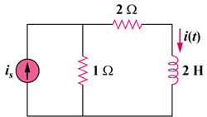

Figure 17.68
For Prob. 17.32.

Solution

When i_{s} = 1 (DC component)

i = 1/(1 + 2) = 1/3

For n 1, ω_{n} = 3n, I_{s} = 1/n²∠0°

I = [1/(1 + 2 + jω_{n}²)]I_{s} = I_{s}/(3 + j6n)

=

Thus,

i(t) =

